**User’s Manual**

FH Mobile Application

Version 1.0

Prepared by

Omar Rivera

Andrew Poirier

Daven Amin

Rick Rejeleene

Table of Contents

[1.0 Download FH 2](#_Toc386118031)

[1.1 Terms of Use 2](#_Toc386118032)

[1.2 Getting Started 2](#_Toc386118033)

[1.3 Initialization and first time running. 2](#_Toc386118034)

[1.4 Create an account. 3](#_Toc386118035)

[1.4.1 User Information 3](#_Toc386118036)

[1.4.2 First Name 3](#_Toc386118037)

[1.4.3 Last Name 4](#_Toc386118038)

[1.4.4 User Type 4](#_Toc386118039)

[1.4.5 Login ID 4](#_Toc386118040)

[1.4.6 Password 4](#_Toc386118041)

[1.4.7 Trainer 5](#_Toc386118042)

[1.4.8 DOB 5](#_Toc386118043)

[1.4.9 Email 5](#_Toc386118044)

[1.4.10 Height 5](#_Toc386118045)

[1.4.11 Weight 6](#_Toc386118046)

[1.4.12 Address 6](#_Toc386118047)

[1.4.13 Balance 6](#_Toc386118048)

[1.5 Workout Information 6](#_Toc386118049)

[1.5.1 Select Date 7](#_Toc386118050)

[1.5.2 End Date 7](#_Toc386118051)

[1.5.3 Frequency 7](#_Toc386118052)

[1.5.4 Metric 8](#_Toc386118053)

[1.5.5 Metric –Time 8](#_Toc386118054)

[1.5.6 Metric -Repetition 8](#_Toc386118055)

[1.5.7 Metric – Distance 8](#_Toc386118056)

[1.5.8 Description 8](#_Toc386118057)

[1.6 Existing User 9](#_Toc386118058)

[1.7 Trainer’s Page 9](#_Toc386118059)

[1.8 User’s Page 10](#_Toc386118060)

[2.0 Menus 12](#_Toc386118061)

[2.0.1 Workout 12](#_Toc386118062)

[2.0.2 User Info 13](#_Toc386118063)

[2.0.3 About 14](#_Toc386118064)

[2.0.4 Login 15](#_Toc386118065)

[2.1 Detailed Operating 16](#_Toc386118066)

[2.1.2 Top Screen icons 16](#_Toc386118067)

[2.1.3 Bottom Screen icons 16](#_Toc386118068)

# 1.0 Download FH

## 1.1 Terms of Use

The App is only for Demonstration purposes for CSC 505 Class.

The Developers holds no responsible for whatsoever.

## 1.2 Getting Started

Refer the Software manual to install the Fitness Health Application.

Open the mobile application on your device, which is running android operating system.

## 1.3 Initialization and first time running.

After you open the application, you can see the main page, which contains the login

form along with the new user registration .

## 1.4 Create an account.

Every User or Trainer needs to create an account when they enter the app for the first time.

Click register, which will lead you to the User Information page.



### 1.4.1 User Information

The User Information page contains the list of information that a new user needs to enter for registering.

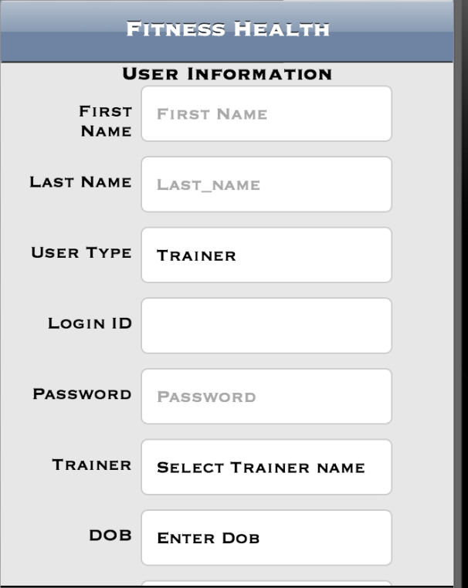

### 1.4.2 First Name

Enter your first name in the form.

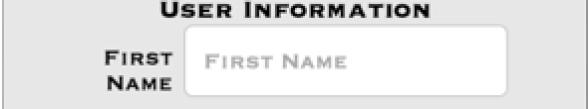

### 1.4.3 Last Name

Enter your Last name in the form.



### 1.4.4 User Type

Enter the User Type

Trainer: The trainer who can verify the user.

User: The User who will do the workouts.

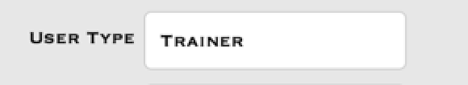

### 1.4.5 Login ID

Enter the Login ID.



### 1.4.6 Password

Enter the Password



### 1.4.7 Trainer

Select the Trainer name

A List of Trainers will appear.



### 1.4.8 DOB

Enter your Date of Birth



### 1.4.9 Email

Enter your Email ID.



### 1.4.10 Height

Enter your Height.



### 1.4.11 Weight

Enter your Weight.



### 1.4.12 Address

Enter your Address

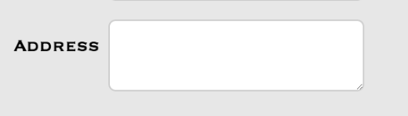

### 1.4.13 Balance

This will display the default balance for the user.



Click Submit after you finish all the above steps.

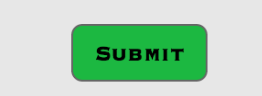

## 1.5 Workout Information

The Next Step is to enter the workout Information.

This will contain the workouts wants to do.

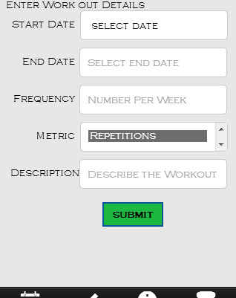

### 1.5.1 Select Date

Enter the start date for your workout.

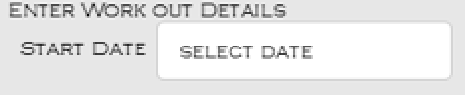

### 1.5.2 End Date

Enter your end date for your workout.

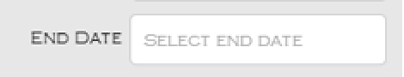

### 1.5.3 Frequency

Enter the frequency for your workout in numbers.

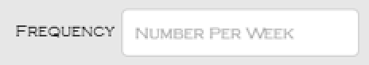

### 1.5.4 Metric

This will contain three different types of activities

### 1.5.5 Metric –Time

::Screenshots of FH:metric_time.png

This type of activity will calculate the time of workout.

### 1.5.6 Metric -Repetition

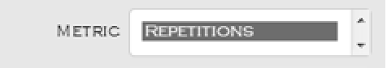

This type of activity will calculate the repetitions of workout.

### 1.5.7 Metric – Distance

This type of activity will calculate based on the distance.

::Screenshots of FH:metric_distance.png

### 1.5.8 Description

Enter the Description for your workout

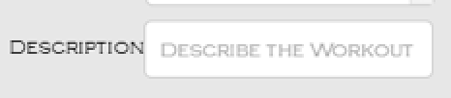

## 1.6 Existing User

An Existing User can login into the system by entering the user name and password on the login screen

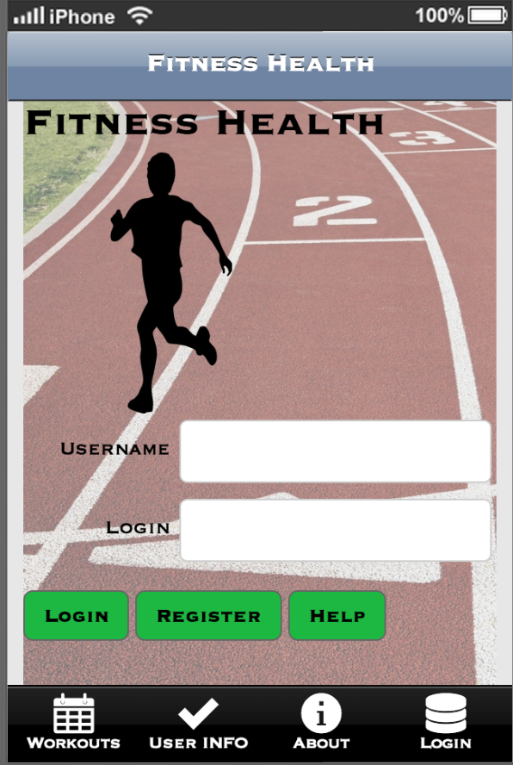

## 1.7 Trainer’s Page

After you login,

If you are a trainer, the trainer page will appear.

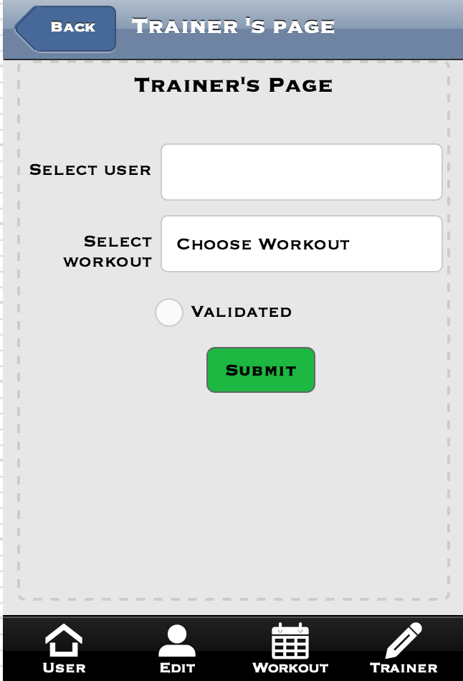

## 1.8 User’s Page

If you are a User, the user page will appear which will contain the list of your workout activities

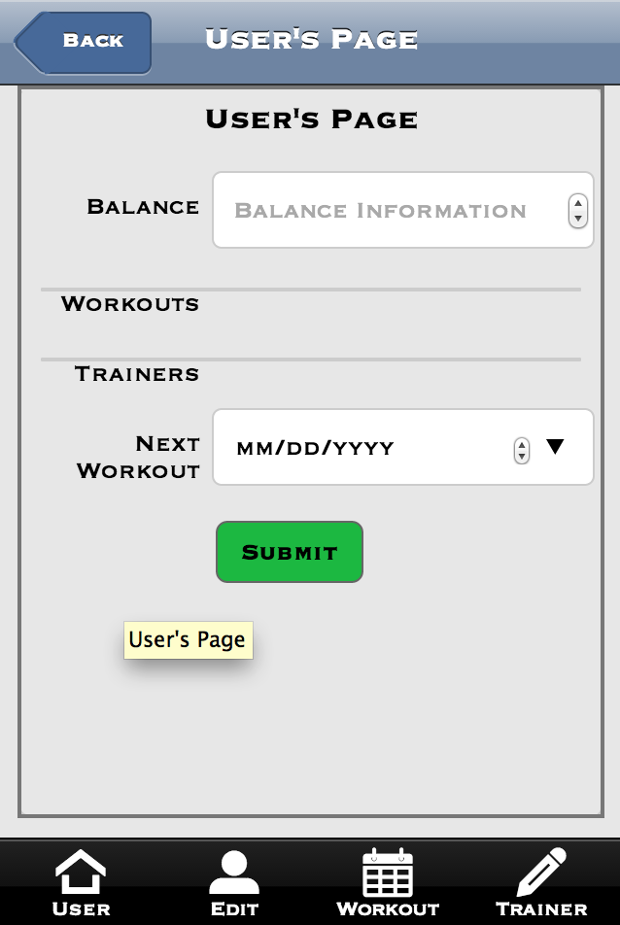

# 2.0 Menus

Simple Menu’s are used in the FH mobile App.

### 2.0.1 Workout

Clicking on the Workout menu will take the user to the workout page



The Workout Page will appear



### 2.0.2 User Info

User info menu will take the user to User info page.



The User info Menu takes to the User Information page



### 2.0.3 About

When you click on About menu, it will take you to the about Page



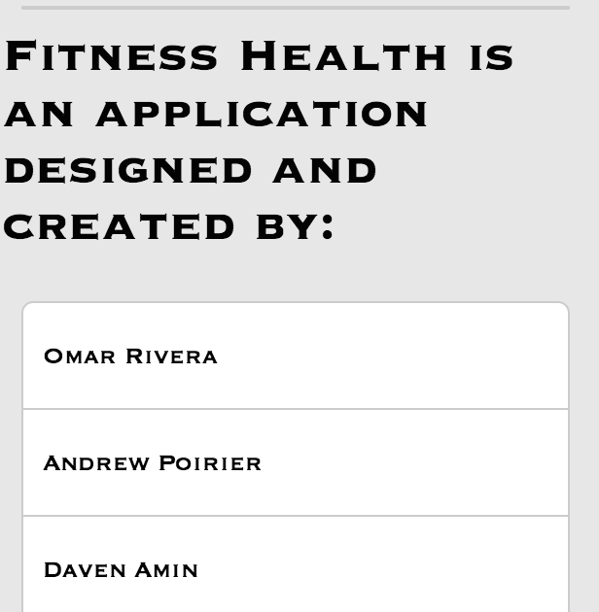

### 2.0.4 Login

The Login button will take you to the Login screen





## 2.1 Detailed Operating

### 2.1.2 Top Screen icons

The Top Screen doesn’t have any icons except the title of the Application.

### 2.1.3 Bottom Screen icons

User –When the user clicks on this, User will contain the user information about the workouts.

Edit – When the user clicks on this, User can edit their information by using this.

Workout – The Workout will contain the workout information for each user.

Trainer – The Trainer icon will let the user to choose or change their trainer.

